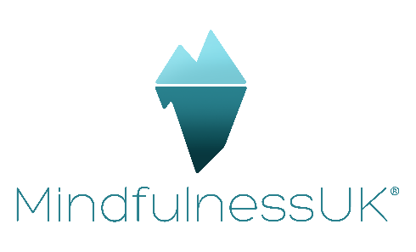
Modern Slavery Policy
This statement, signed by Karen Atkinson on 24th April 2024, CEO MindfulnessUK, is our response to the UK’s Modern Slavery Act 2015. It sets out the steps we have taken from 2023-2024 to ensure our supply chains are slavery-free.
Our purpose is to champion better mental health in all sectors. We wholeheartedly endorse the UK’s Modern Slavery Act 2015. The requirement for transparency across supply chains is a cruciallly important development in tackling slavery and human trafficking.

Our purpose and structure
MindfulnessUK is the mindfulness and compassion training and teacher training organisation and our purpose is to support the mental health and wellbeing of all.
We are a private organisation with a few employees, mainly part-time, plus a number of supportive consultants.

Our supply chains
Our supply chains include all printers, IT services, conference and venue suppliers, training providers and consultants, and marketing and PR services. We procure these services both centrally, from our head office in the UK, and globally if required.

Our policies and processes
We have appropriate processes and policies in place to mitigate the risk of modern slavery and human trafficking in our organisation and supply chains. Our Audit and Risk Committee reviews and approves these policies every two years.
Our procurement process requires all suppliers and contractors to comply with the Modern Slavery Act 2015, and we expect them to demonstrate a zero-tolerance approach to exploitation. Our standard terms and conditions for the purchase of goods and services allow for termination in the event of non-compliance.
We take a zero-tolerance approach to modern slavery. We are committed to combatting slavery and human trafficking, and to acting ethically, transparently and with integrity in all of our transactions and relationships.

Our people
We provide regular training to all our people to increase their awareness of modern slavery and human trafficking so they’re able to understand, identify and report on these risks. We are committed to maintaining an honest and ethical culture, ensuring our people are aware of our anti-bribery policy and zero-tolerance approach to bribery and corruption.

Governance and compliance
This statement is made pursuant to section 54(1) of the Modern Slavery Act 2015 and constitutes our slavery and human trafficking statement for 2023-2024.

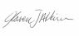
CEO Karen Atkinson

